

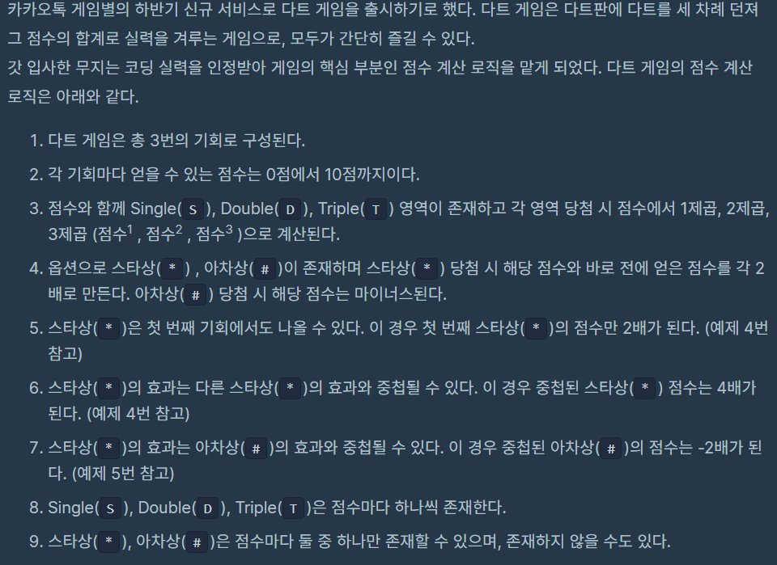

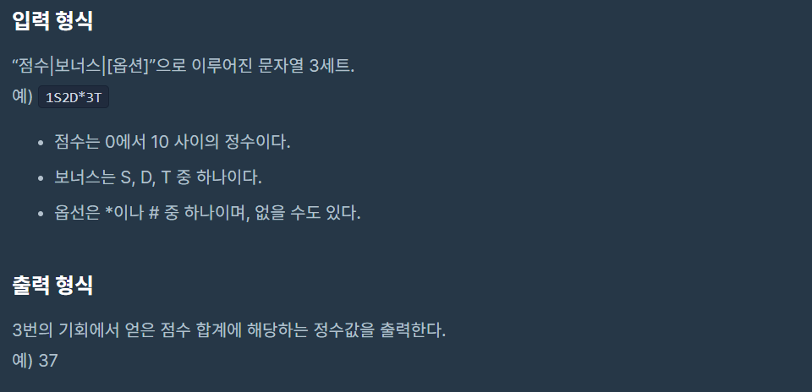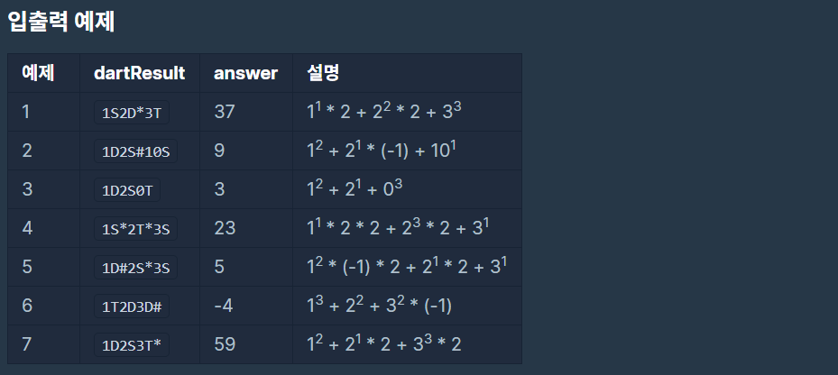

**문제 링크주소 :** <https://programmers.co.kr/learn/courses/30/lessons/17682>

**풀이**

function solution(*dartResult*) {

    var answer = 0;

    var arr = *dartResult*.split("");

    for(var i =0; i<arr.length; i++){

        if(arr[i]==0 && arr[i-1]==1){

            arr.splice(i,1);

            arr[i-1]="10";

        }

    }

    var answerArr = [];

    function cal(*n*){

        if(arr[*n*+1] =="*"){

            if(arr[*n*] == "S"){

                answerArr.push(Math.pow(arr[*n*-1],1)*2)

            }

            else if(arr[*n*]=="D"){

                answerArr.push(Math.pow(arr[*n*-1],2)*2)

            }

            else if(arr[*n*]=="T"){

                answerArr.push(Math.pow(arr[*n*-1],3)*2)

            }

        }

        else if( arr[*n*+1] == "#"){

            if(arr[*n*] == "S"){

                answerArr.push(Math.pow(arr[*n*-1],1)*(-1))

            }

            else if(arr[*n*]=="D"){

                answerArr.push(Math.pow(arr[*n*-1],2)*(-1))

            }

            else if(arr[*n*]=="T"){

                answerArr.push(Math.pow(arr[*n*-1],3)*(-1))

            }

        }

        else{

            if(arr[*n*] == "S"){

                answerArr.push(Math.pow(arr[*n*-1],1))

            }

            else if(arr[*n*]=="D"){

                answerArr.push(Math.pow(arr[*n*-1],2))

            }

            else if(arr[*n*]=="T"){

                answerArr.push(Math.pow(arr[*n*-1],3))

            }

        }

    }

    cal(1);

    if(arr[2] =="*"|| arr[2]=="#"){

        cal(4);

        if(arr[5] =="*"|| arr[5]=="#"){

            if(arr[5]=="*"){

                answerArr[0] = answerArr[0]*2;

                cal(7);

                if(arr[8]=="*"){

                    answerArr[1] = answerArr[1]*2;

                }

            }

            else if(arr[5]=="#"){

                cal(7);

                if(arr[8]=="*"){

                    answerArr[1] = answerArr[1]*2;

                }

            }

        }

        else{

            cal(6);

            if(arr[7]=="*"){

                    answerArr[1] = answerArr[1]*2;

            }

        }

    }

    else{

        cal(3);

        if(arr[4] =="*"|| arr[4]=="#"){

            if(arr[4]=="*"){

                answerArr[0] = answerArr[0]*2;

                cal(6);

                if(arr[7]=="*"){

                    answerArr[1] = answerArr[1]*2;

                }

            }

            else{

                cal(6);

                if(arr[7]=="*"){

                    answerArr[1] = answerArr[1]*2;

                }

            }

        }

        else{

            cal(5);

            if(arr[6]=="*"){

                answerArr[1] = answerArr[1]*2;

            }

        }

    }

    answer = answerArr[0]+answerArr[1]+answerArr[2]

    return answer;

}